SUBMIT YOUR EN
A multistakeholder international and national approach to build an integrity culture
the case of Italy

AWARD OPEN GOV – INSPIRATIONAL REFORM. *

- In 100 words or less, please describe any nomination or consultation process held with civil society partners or others when selecting the reform.IO

The PoC with the experts of the Italian Task force for open government selected 3 main reform initiatives: the results of the implementation of “public debates” in the realization of national infrastructures in the domain of the NRRP; the publication by the anticorruption Authority of an open data dashboard on national projects for transparency purpose and the national approach of preventing corruption.

During its 9th of May meeting the MSF has discussed and selected the last one as the inspirational more successful reform. The decision was publicly announced during the closing on line event of the Open Gov Week 2023.

2. If you have a letter of support from those who were consulted, please upload it.

3. In 200 words or less, please describe the specific problem the reform intends to solve. Why was this problem important to solve at a particular time in your context?

To manage a multifaced phenomenon like corruption there is a need for knowledge, expertise and a systematic exchange of information and data among different actors, including civil societies organizations (CSOs) and citizens.

In Italy until a few years ago the regulatory system was particularly biased towards repressive approaches to corruption, while there was no structured prevention system and the practices were fragmented and not open to civic participation.

The introduction of a National Authority for Corruption Prevention (ANAC) in 2014 changed the scenario. However, there were remaining “blind spots” in regulating the institutional synergies among the actors involved.

Enabling civil society through legislation or regulation was not enough. To strengthen the collaboration among institutions and at the same time encourage civil society engagement in preventing corruption was then foreseen as the main policy to be implemented. This was prioritized also to account for the decrease of Italian citizens’ trust in public authorities.

The government has felt the urgency of enabling a shift in the mindset of both institutions and CSOs, especially as a consequence of the pandemic crisis, when a lot of resources were made available for the recovery planning.

4. In 400 words or less, describe the approaches used in designing this reform. Why do you think they work to solve the problem outlined above? Who benefits from your reform (e.g. a target population)? Are the approaches used in the reform new or have they been tried before?

This reform, initiated by the Italian government at national and then international level during the period 2021-2022, focuses on preventing corruption and promoting the culture of integrity through a permanent platform for dialogue among public and private sector actors and civil society organizations.

This innovative strategic approach was implemented to strengthen the existing legal framework. To foster public integrity and better fight corruption were therefore introduced in Italy coordination mechanisms.

The Italian Presidency of the G20 in 2021 was the opportunity to build a national Coordination Table and a Special Italian G20 task force was set up at the Directorate General for Globalization of the Ministry of Foreign Affairs and International Cooperation (MAECI) to support the Italian Presidency of the G20, in particular with regards to the G20 Anti-Corruption Working Group (ACWG).

This model of coordination was also applied in the domain of the Italian activities for implementing open government principles introducing a more strategic approach.

In continuity with the successful experience of the G20 2021 task force and in synergy with the anti-corruption national Coordination Table, in the Italian Fifth National Action Plan (5NAP) was then included the creation of “Networks for integrity and transparency”.
The commitment, coordinated by ANAC, focuses on means of employment and monitoring of funds from the National recovery and resilience plan. A specific multistakeholder task force coordinated by ANAC was established to further develop synergies in line with the open government principles and to enhance the exchange of practices.

In order to highlight the best practices a twofold approach was adopted :
- promoting and enhancing the national experience in anti-corruption, anti-fraud, anti-money laundering at international level, presenting the Italian system;
- analysing how other countries are adapting their systems to face the same emerging challenges in the context of their national plans and more generally anti-corruption/anti-money laundering/anti-fraud strategies in times of crisis and recovery.

Built on general recommendations and standards in the field such as the G20 High-Level Principles on Preventing and Combating Corruption in Emergencies, the proposed approaches acknowledge the “positive role played by stakeholders outside the public sector in preventing and combating acts of corruption during crisis and emergencies”.

Civil society, academia and media are indeed a pivotal component of the promotion of transparency and accountability, identifying, detecting and reporting corruption.

5. In 400 words or less, describe the impact the reform has had, or intends to have. If the reform had an impact, what were they? For example, did the reform demonstrably improve people’s lives, save the taxpayer money, lead to policy or regulatory change, replicated in new areas and with more people? If the reform is new, describe how it will add value to people, and why it is the best possible solution to solving the problem in your unique context (e.g., cost and time effective). Describe its potential to be scaled, replicated or adapted in other geographies, populations or institutions.

The described approaches are innovative for Italy due to the integration of roles, functions, competences, knowledge and best practices circulation put in place. In the context of the ACWG G20 important documents have been released referring to topics including measurement of corruption, corruption during crisis and caused by organized crime.

A compendium of best practices for measuring corruption were published, gathering all the methodologies used to promote improvement in this field.

All multilateral documents approved during 2021 have ensured compliance with the fundamental principles of the legal system, recognising Italy’s anticorruption leadership. Moreover they contributed to a comprehensive analysis of the new forms of corruption that threaten and undermine democracies worldwide in the current context of crisis and citizens’ trust decline.

This approach yielded the planning of two commitments translated in the 5th NAP for open government:

- “Strategies and networks for integrity and transparency”, led by the ANAC.
- “Community of practice of responsible for the prevention of corruption and transparency” where CSOs and PAs empower each other through the exchange of experience, led by the National School for Administration (NSA)
Both initiatives set up a platform for dialogue with the aim to integrate strategies, policies and operative solutions.
As results the latter has been inserted in the Compendium of good practices of the G20 Anticorruption Working Group released last November together with another NSA’s activity: “Training for change. Open administration and innovative training models for the efficient implementation of whistleblowing”, a survey involving about 6000 civil servants that aims to highlight the role of training related to perceptions of whistleblowing, as whistleblowing is not yet fully rooted in Italian culture and legal experience.
In terms of impact, we consider:
- the empowerment of CSOs, challenged to play a role in monitoring and providing support to anticorruption policies implementation;
- the stakeholders’ drive towards a culture of integrity, moving away from a compliance-based, bureaucratic approach and endorsing a competence-based, human-centred, open and participatory one;
- the co-chairing of the new 2023 G20 ACWG involving Italy whose leadership on anticorruption has been recognised by Indonesia.
The dialogue with civil society will also contribute to the definition of a new framework of competences needed in order to deal with public decision-making processes and for managers to be held accountable. Together with a more comprehensive knowledge of new corruptive phenomena, a culture of integrity that enables managers to deal with conflicts of interests and whistle-blowers is emerging.

6. Please identify up to 5 individuals from government, civil society and other partners who worked on this reform. These individuals may be requested to speak about the initiative during the OGP Global Summit in Estonia.

- Giovanni Tartaglia Polcini, Co-chair, G20 ACWG, MAECI
- Giuseppe Busia, President of ANAC
- Federico Anghelè, The Good Lobby
- Paola Caporossi, Fondazione Etica
- Sabina Bellotti, Italian POC for Open Government

7. Please upload 1-2 photos of the initiative that we can use as part of communications and social media.

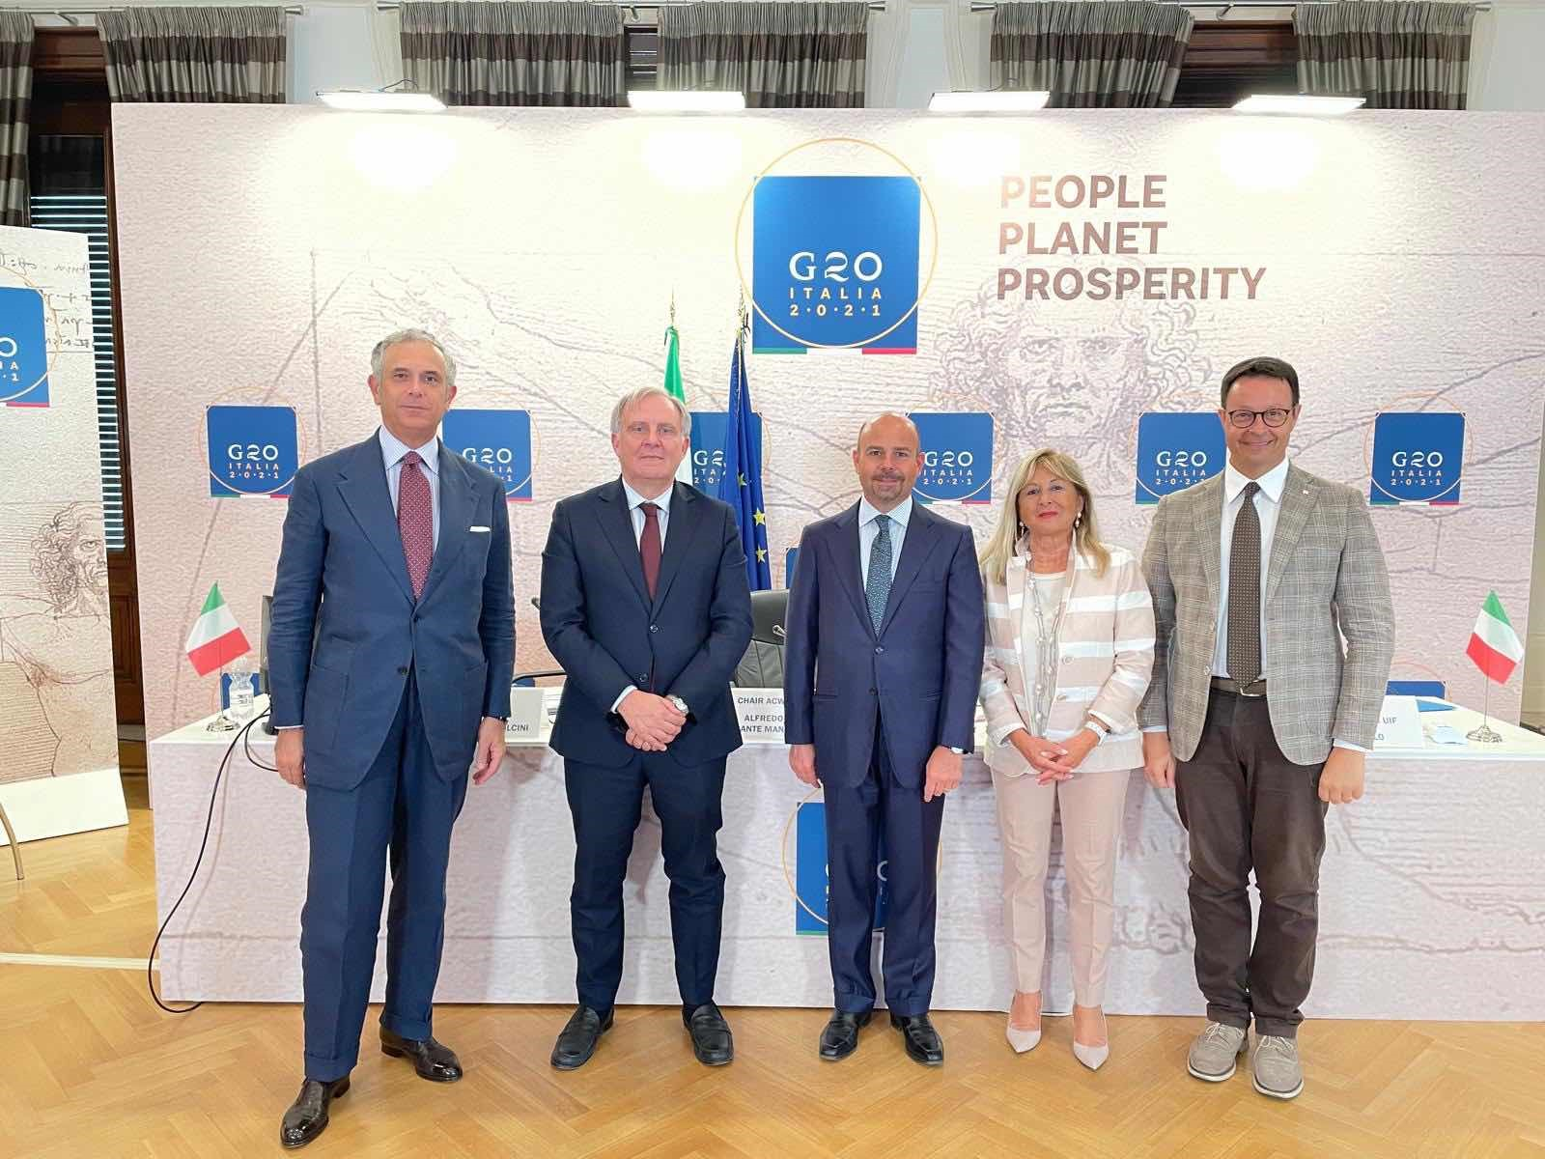

DO
8. Please include any relevant media links, photos or evidence that can support your claims made in this application form.

Documents released from G20 Anti-Corruption Working Group

Compendium of good practices in the G20-2022

5 National Action Plan for Open Government

Community of practices by SNA

